8 Using a Mixin for Media Queries

Turn on your [SASS Watcher](2.png)

In your main.SCSS file

Create a new @mixin after the @mixin for the theme.

  @mixin mobile {

    @media (max-width: 800px) {

        @content;

    }

  }

But instead of defining that 800px directly in the argument list of the media query, we could also define a variable that would represent that number. That way we can change it around if we needed to when we include it and need to fill in the blanks (so to speak)

Create a new variable called @mobile

Remember that in SASS:



You could place this variable at the top of the page, but since we have a partial file name _variables.scss, we could just place this new instantiation of the variable in there.

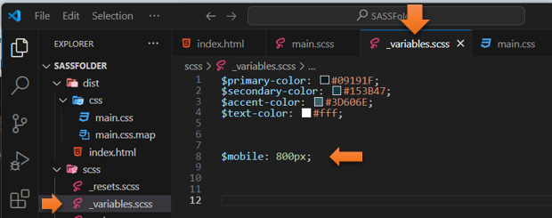

Now back in the main.SCSS file, you can switch out the actual value for the variable

  @mixin mobile {

    @media (max-width: $mobile) {

        @content;

    }

  }